Internal Meeting Minutes

|  |  |
| --- | --- |
| **Date:** | 21/08/17 (Monday) |
| **Time:** | 4.00pm |
| **Venue:** | LKS Library Project Room 4.2 |
|  |  |
| **Attendees:** | Yu Xuan, Yi Xuan, Sheryl, Clarissa, Huiyan, Jeremy |
| **Agenda:** | 1. Preparation for Supervisor Meeting 2. New Tasks on ASANA 3. Database Design 4. Deployment |

**1. Preparation for Supervisor Meeting**

Meeting with Prof Jie Xiong confirmed to be on Wedneday, 23 Aug 17. The team discussed on the items to present and prepared questions to ask Prof Jie Xiong.

**2. New Tasks on ASANA**

Yu Xuan went through with the team the new tasks on ASANA based on client’s request for multiple shipping address for each customer and the ability to give universal promo codes to customers. The team discussed on the feasibility and raised concerns for the current database design.

Team decided to redesign the billing page as per the inspiration below: *default address should be pre-filled

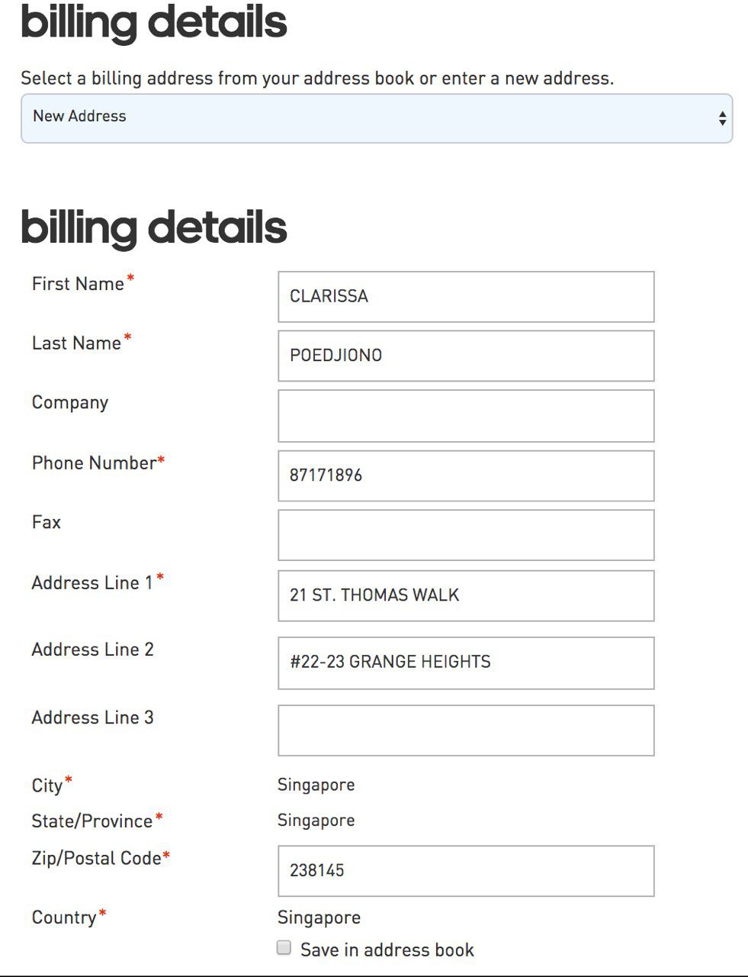

Team discussed on the current UX of adding items to cart and brought up that the cart preview slider has not been done. However, the team discussed and decided to replace that function to a pop-up message as follow:

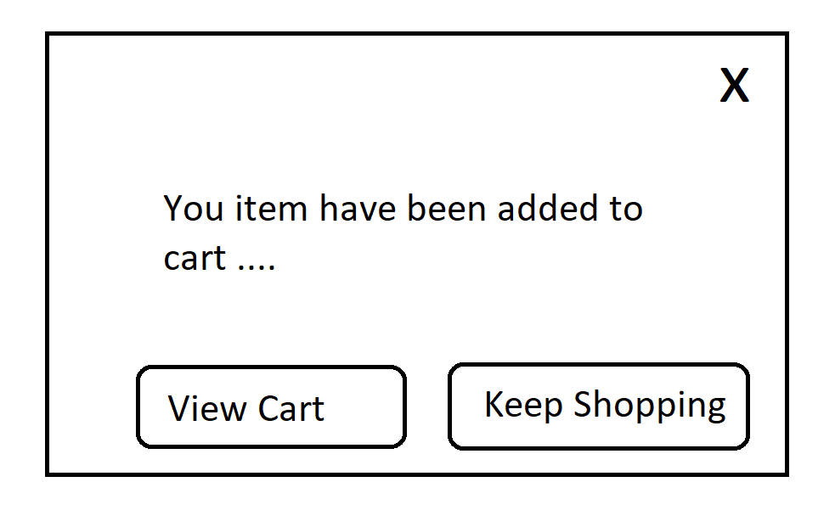

**3. Database Design**

Team raises concern for current database design as it may not be scalable in the future. Hence, team proposed to create tasks to redesign the database to cater for client’s new requirement as well as future scaling purposes. Team decided to meet the next day to redo the database design together.

Things to take note when designing database: Product Ids, Soft delete, multiple address, promo codes, shipping, colour price.

**4. Deployment**

Jeremy demo-ed to the team on how deployment is done for both the front-end and back-end application. Sheryl will create a user guide for deployment.

The meeting was adjourned at 5.00pm. These minutes will be circulated and adopted if there are no amendments reported in the next three days.

Prepared by,

Yi Xuan

Vetted and edited by,

Yu Xuan